**DIGITAL SYSTEMS CLOCK REPORT**

**CS21B042**

**R.SAI KRISHNA**

**COUNTERS:**

**10-counter:**

State diagram:

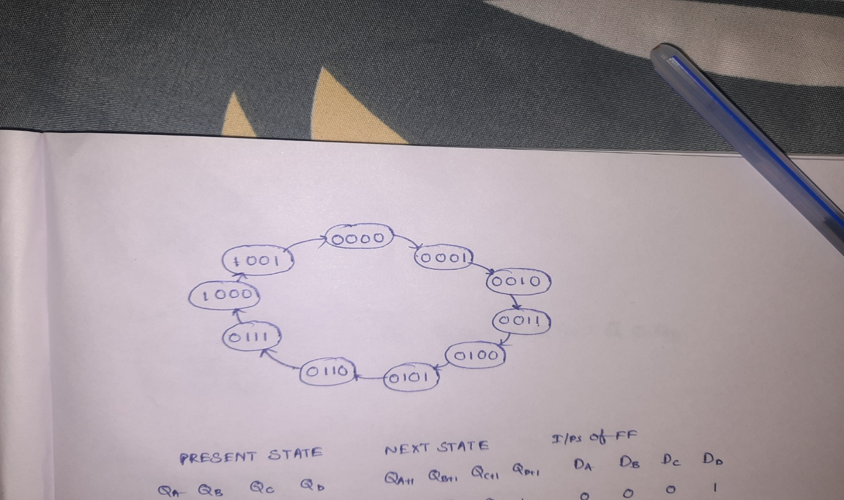

State table:

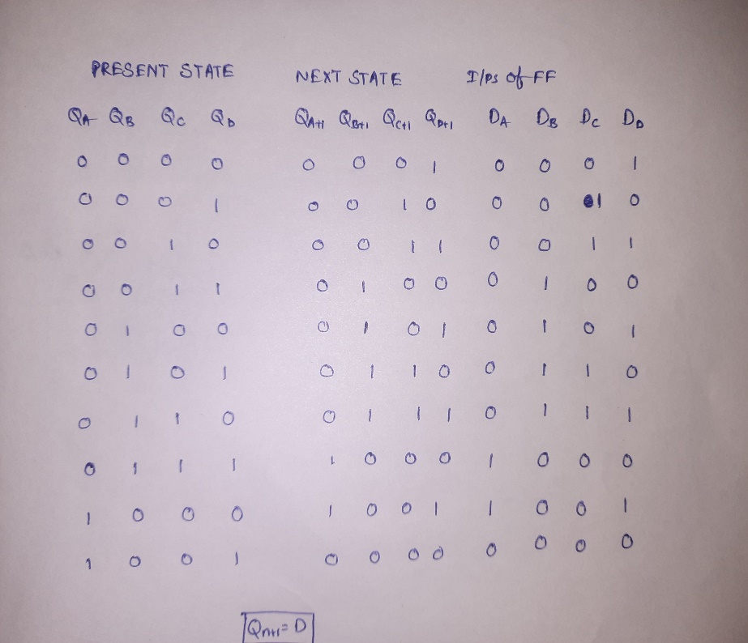

kmap for DA:

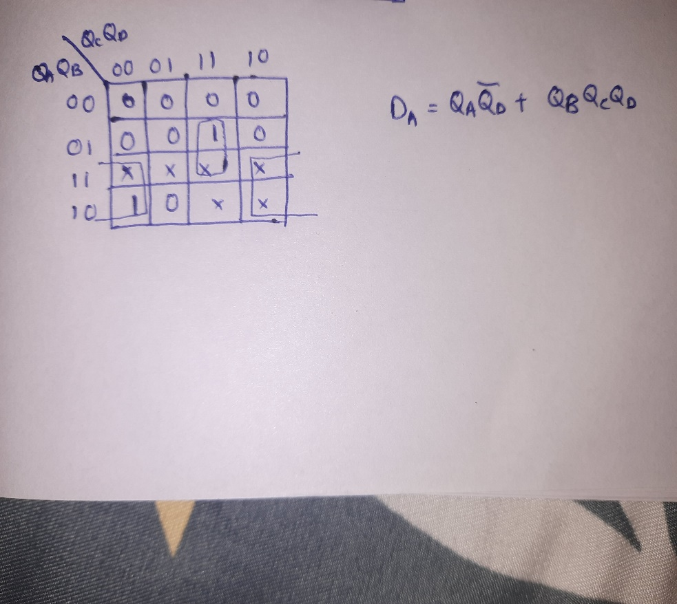

kmap for DB:

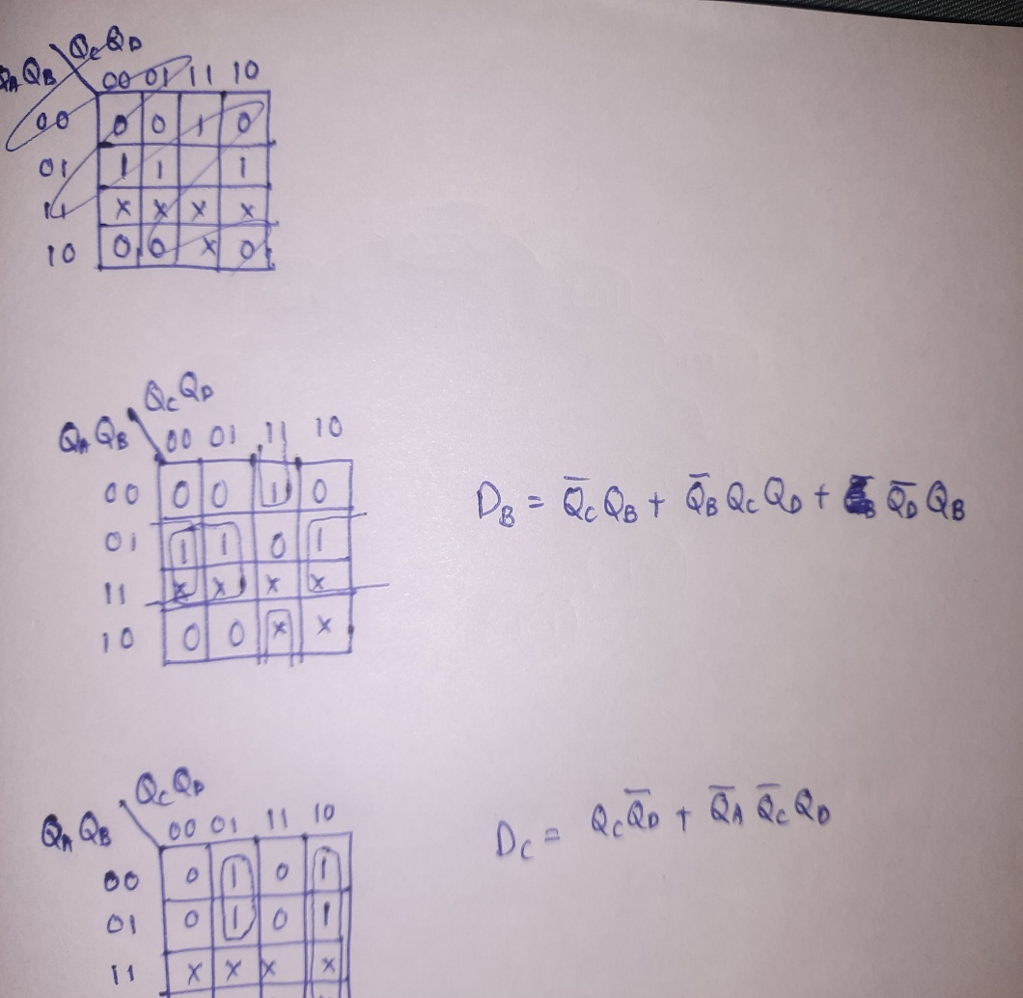

kmap for DC:

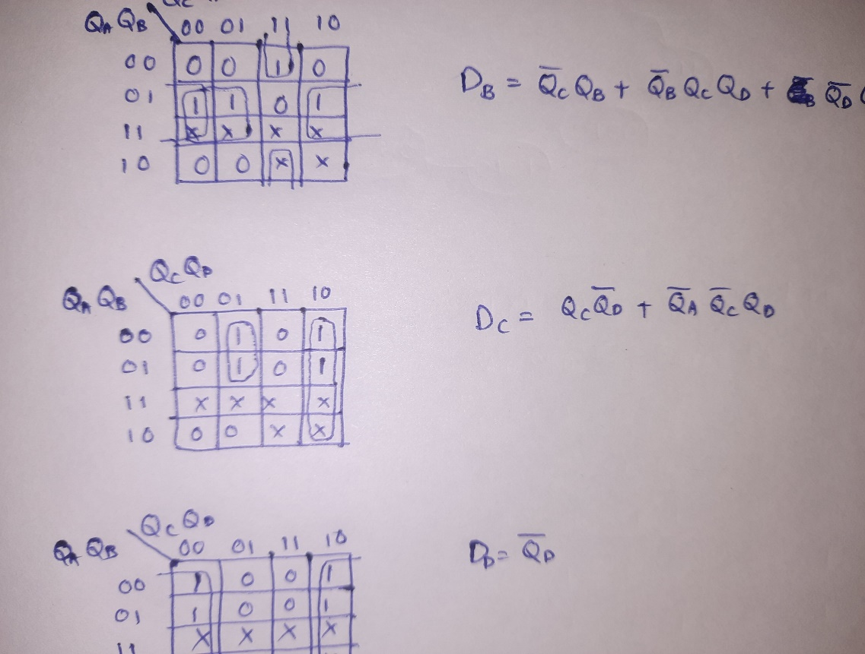

kmap for DD:

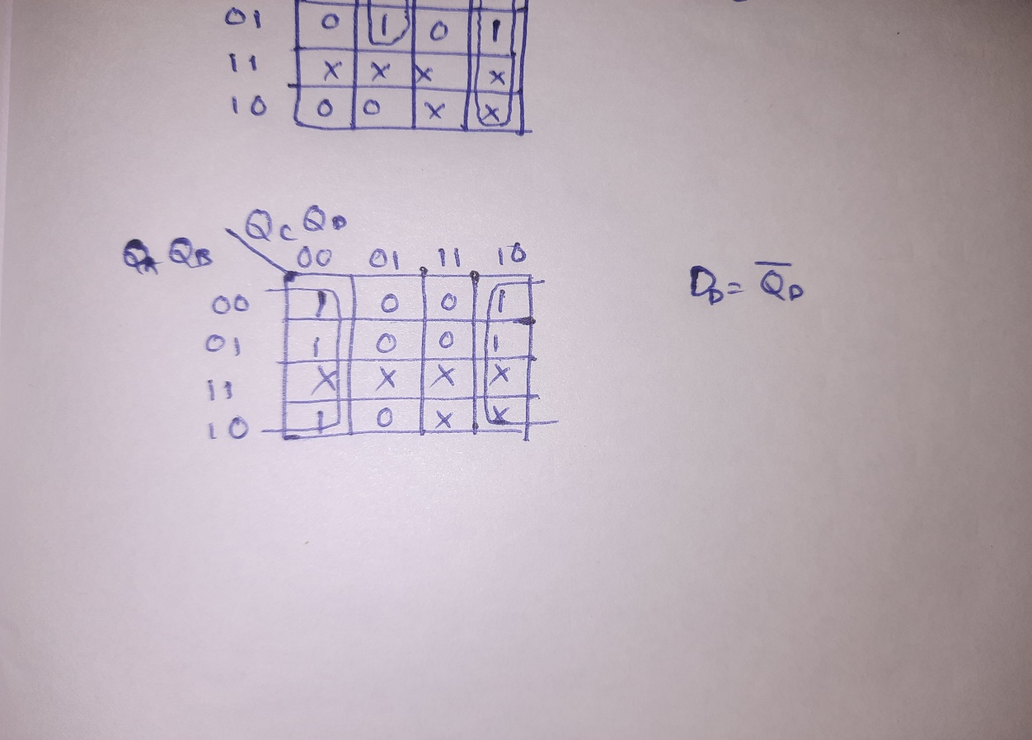

Mod 10 counter circuit :

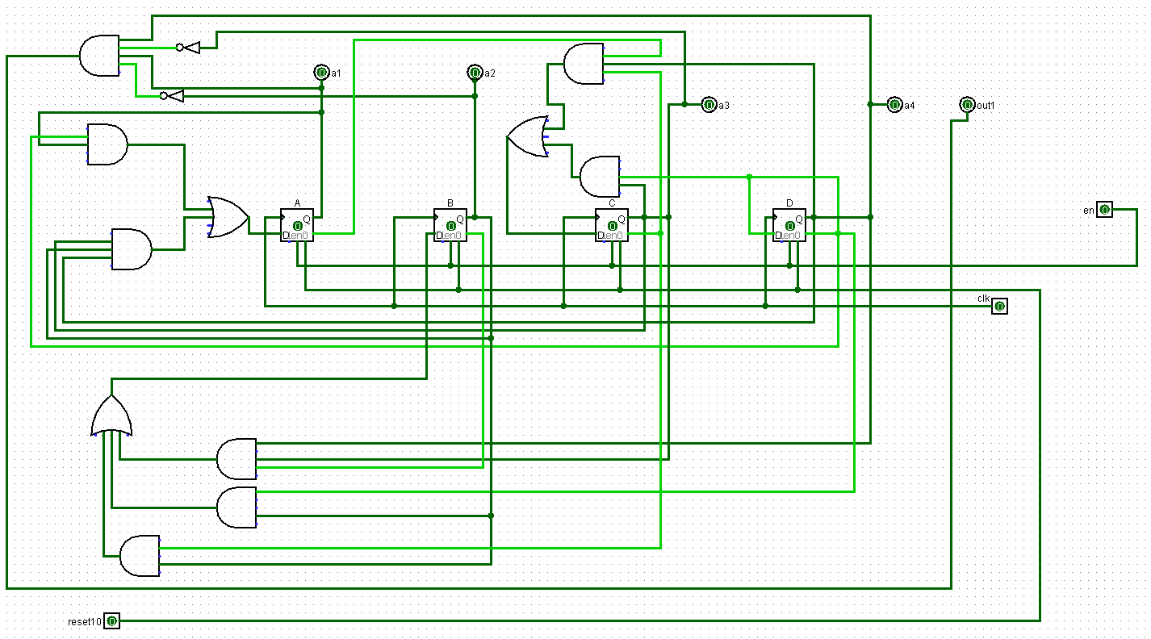

**6-counter:**

State diagram:

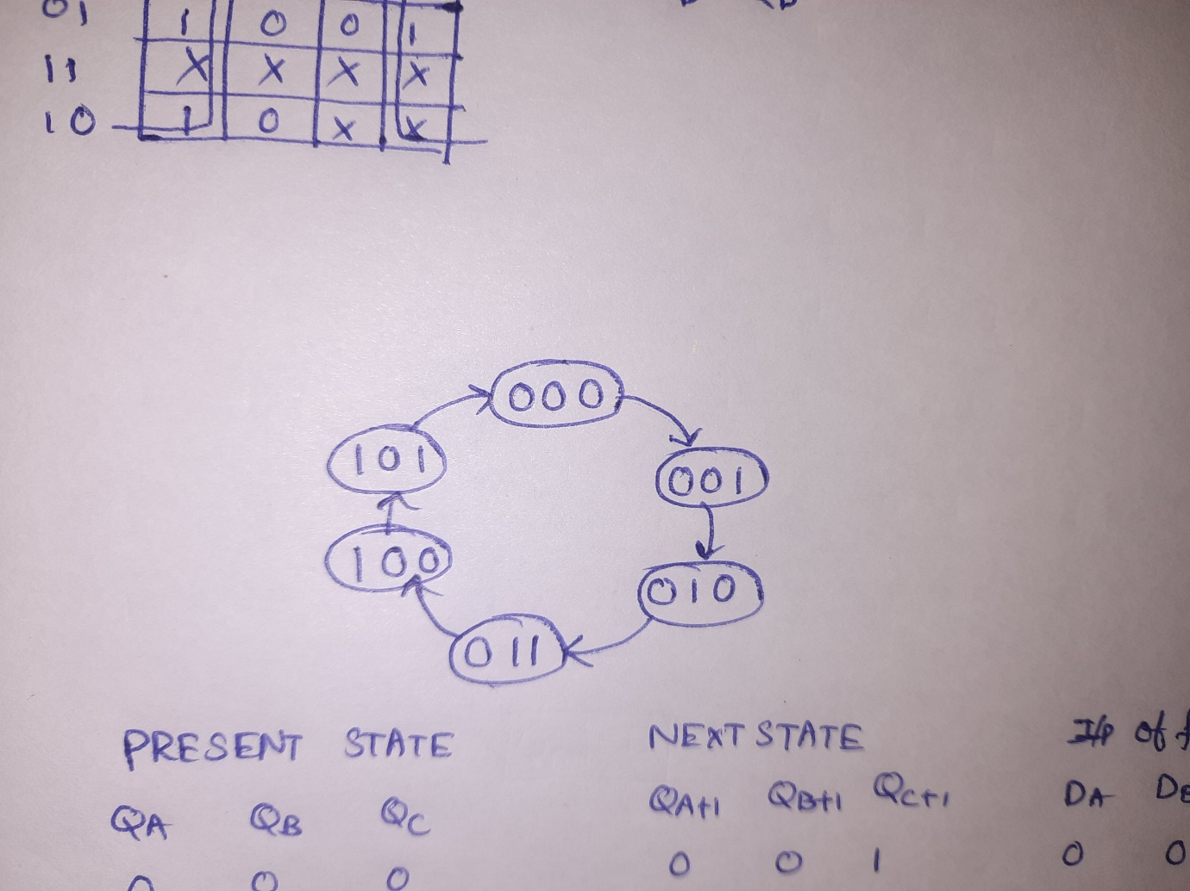

State table:

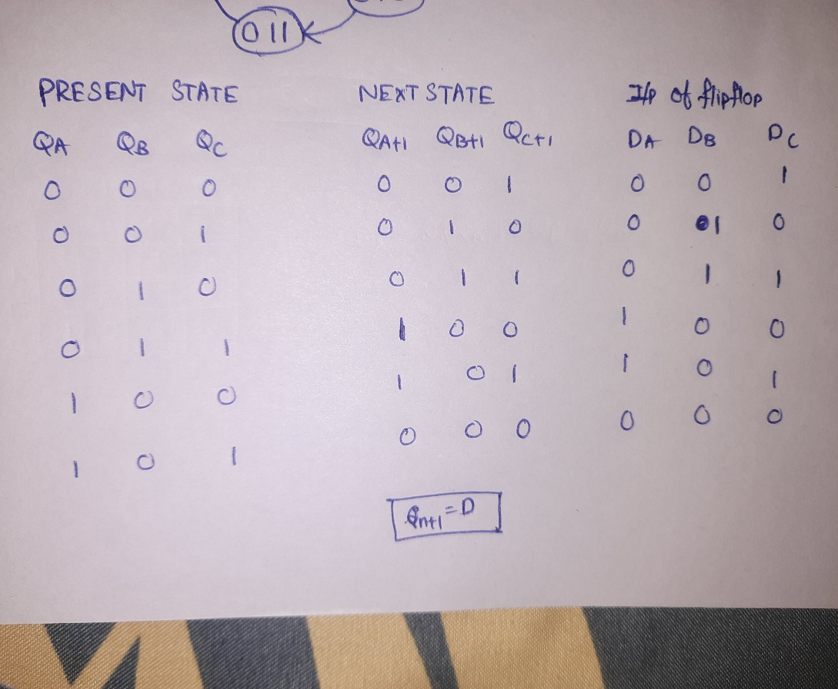

Kmap for DA:

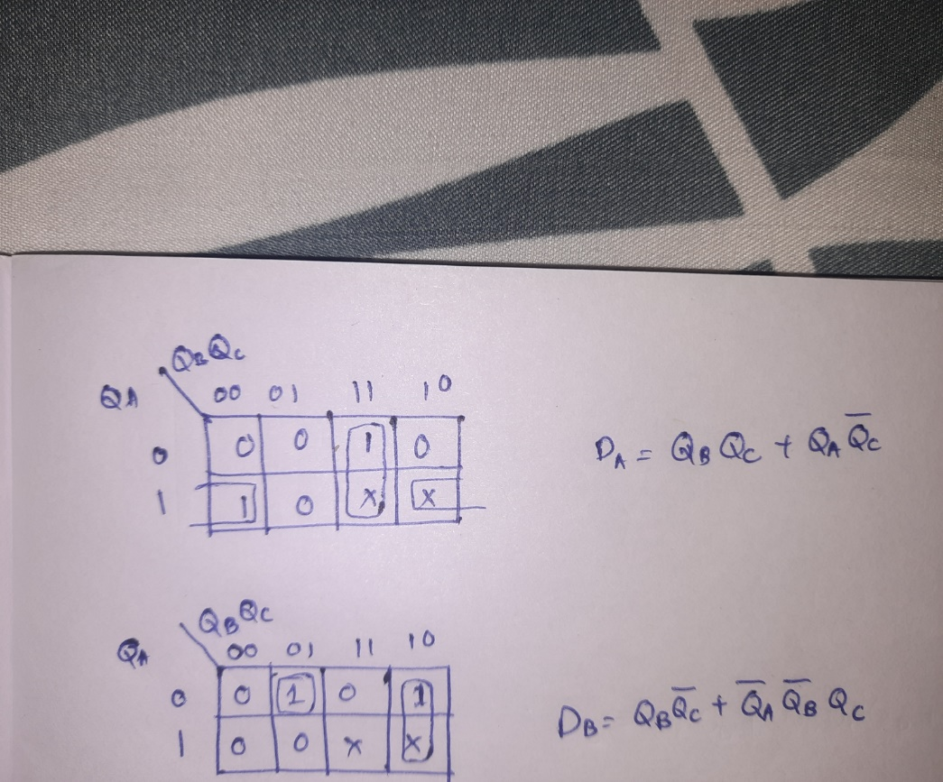

Kmap for DB:

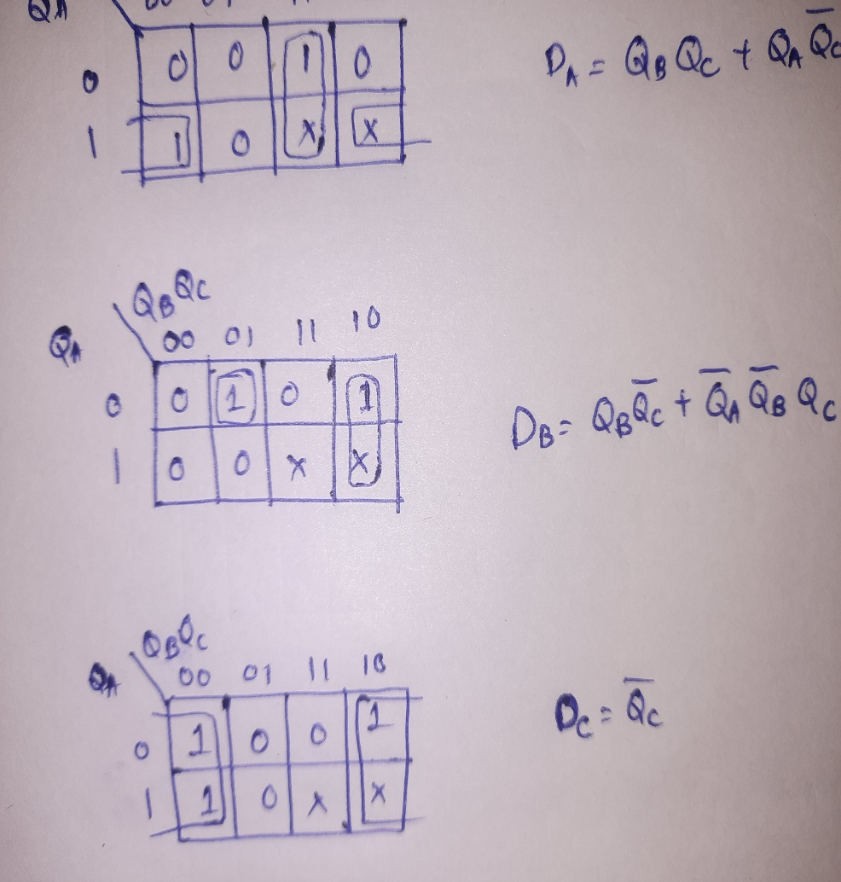

Kmap for DC:

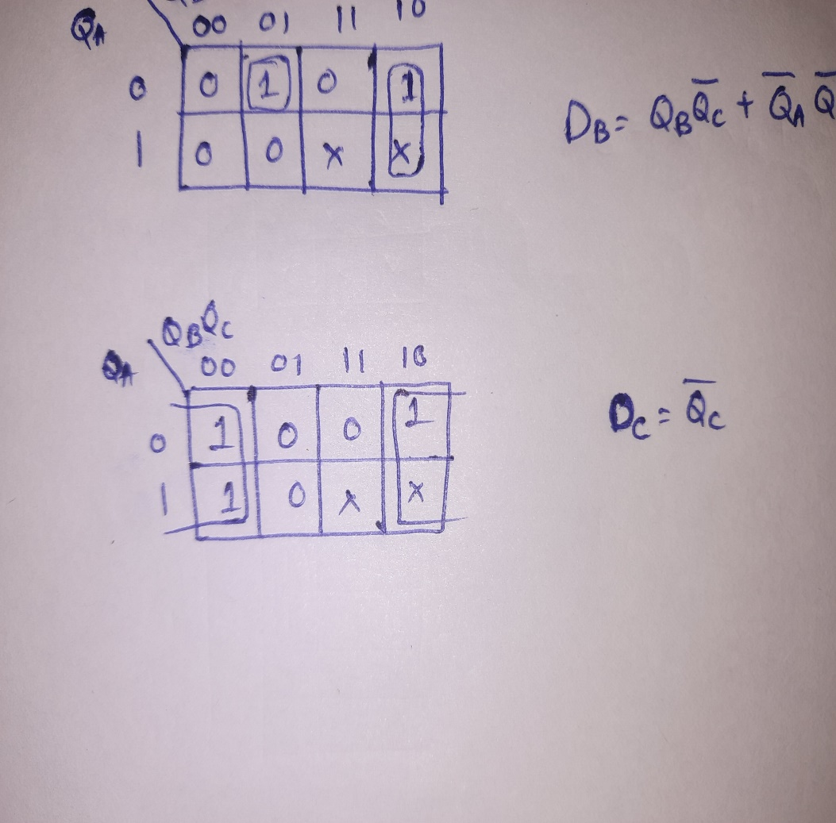

Mod 6-counter circuit :

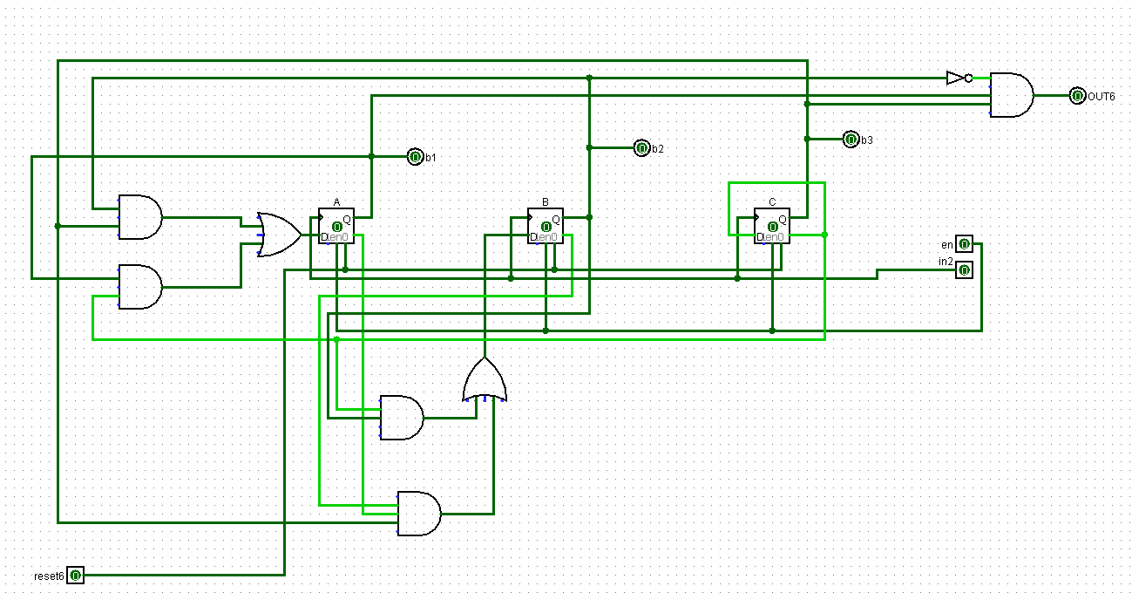

**3-counter:**

State diagram: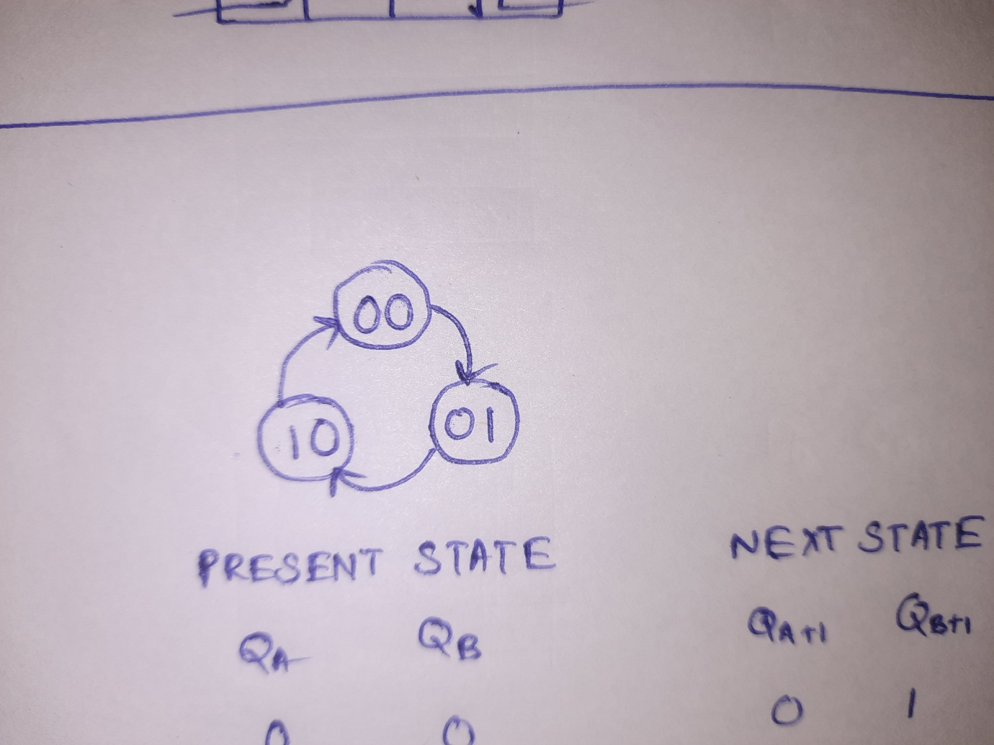

State table:

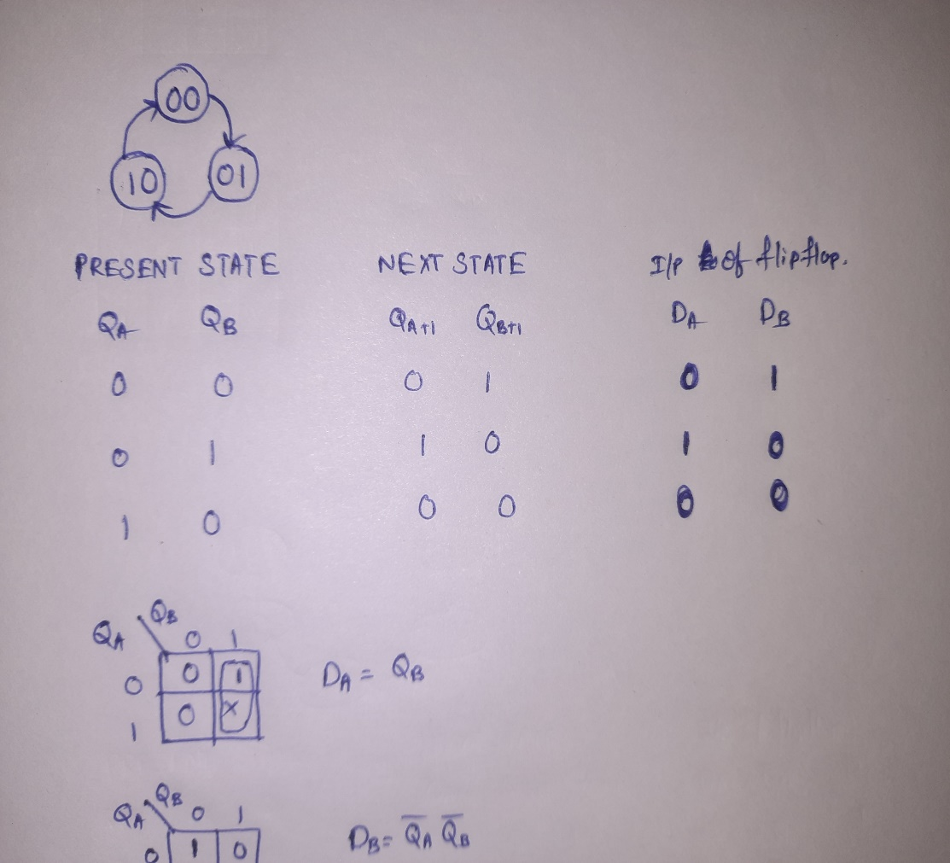

Kmap for DA

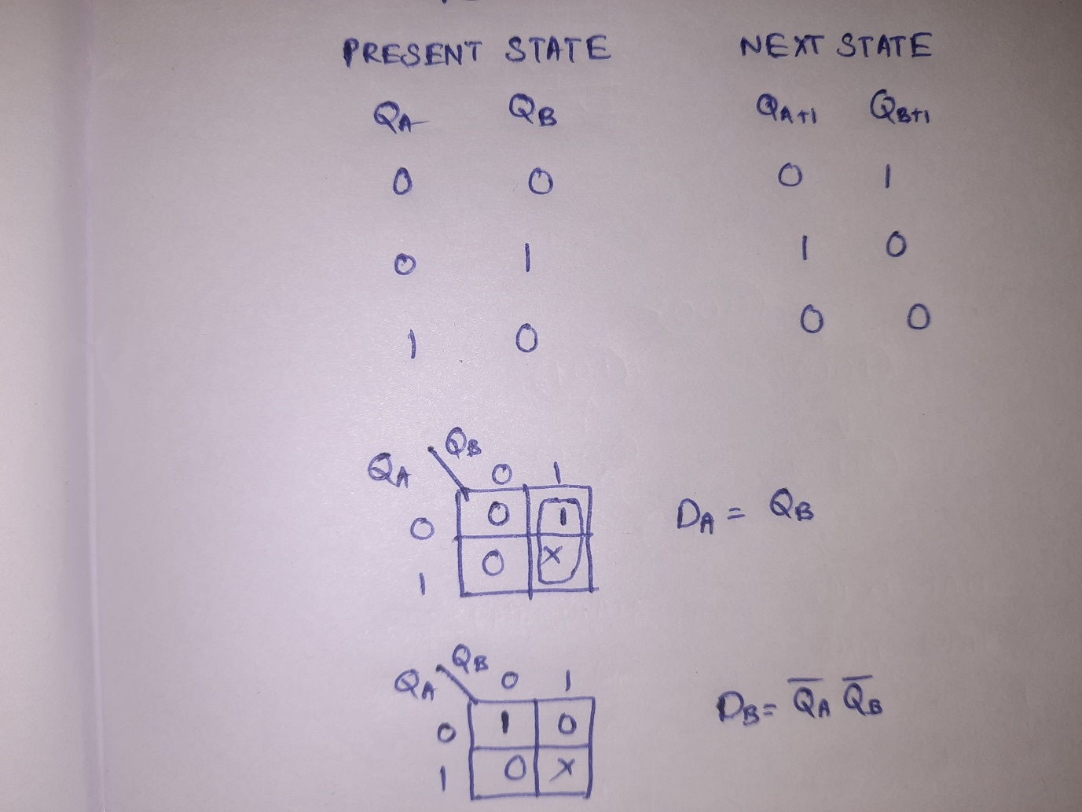

Kmap for DB

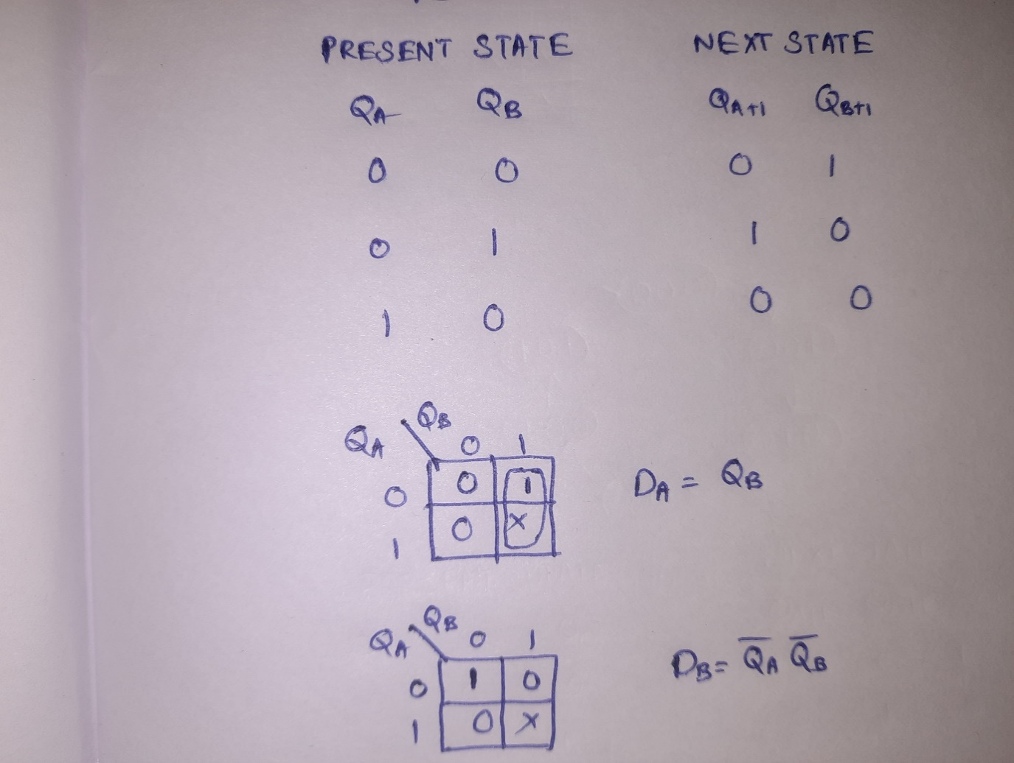

Mod 3-counter circuit:

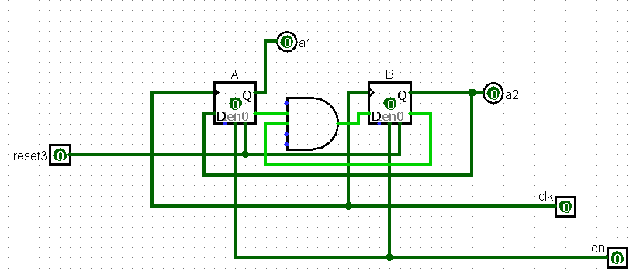

**Binary to 7-segment display Decoder(binary(0 to 9) to 7 segment display)**

Truth table:

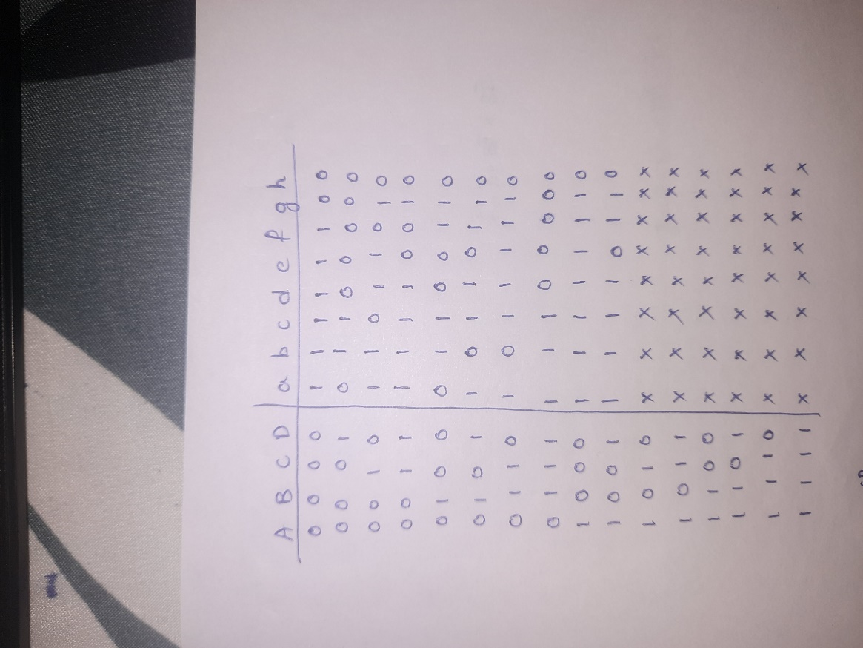

Kmap for a:

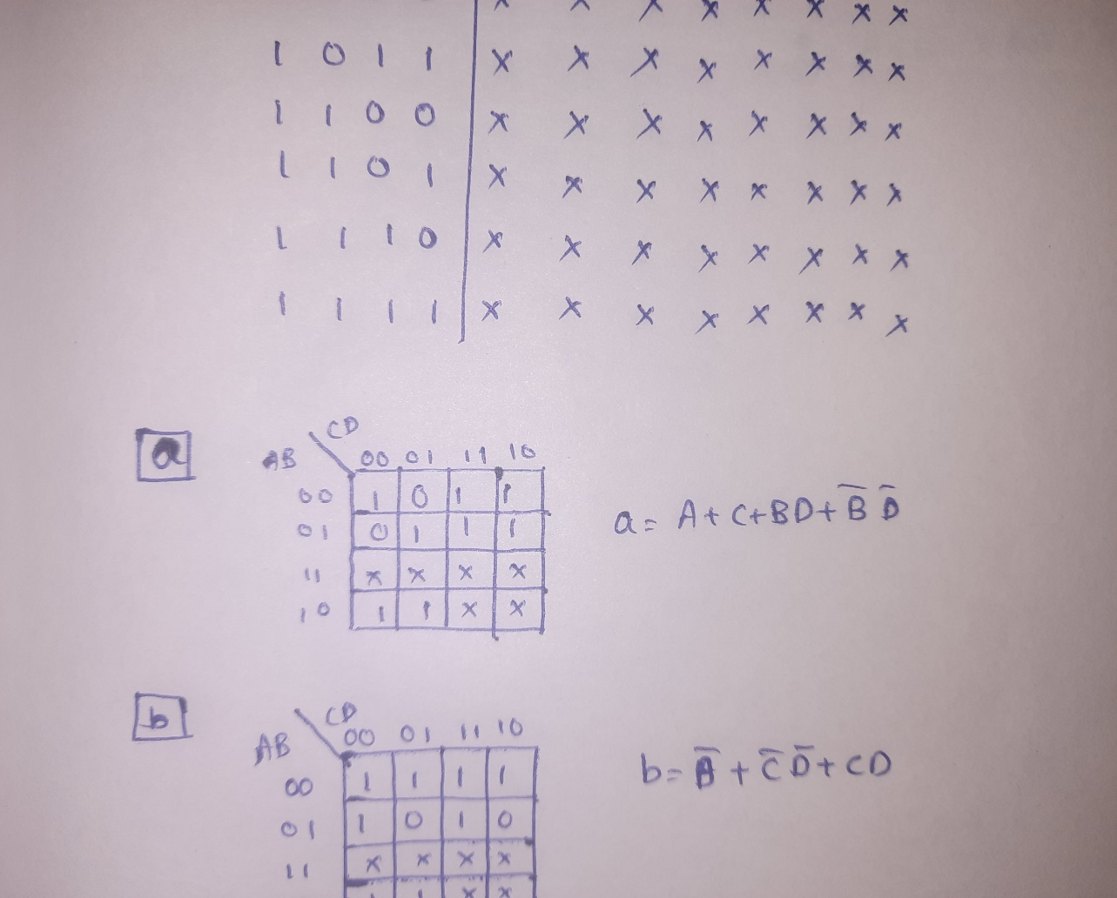

Kmap for b:

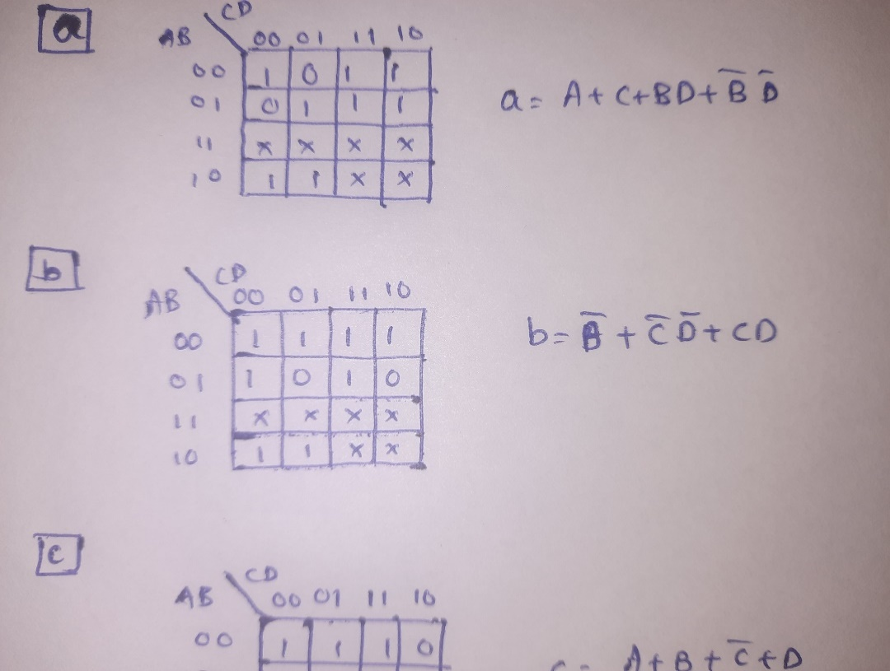

Kamp for c:

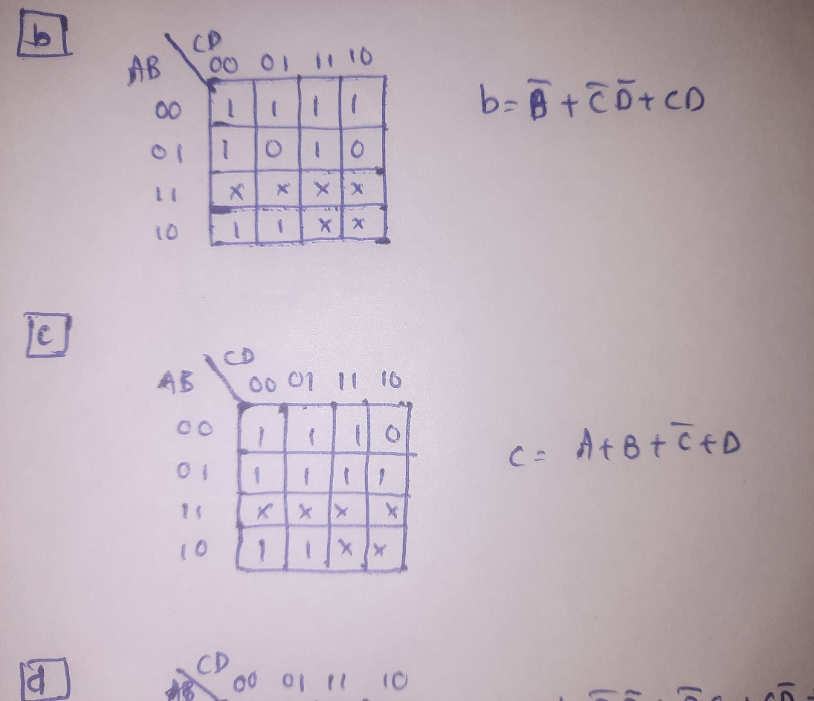

Kmap for d:

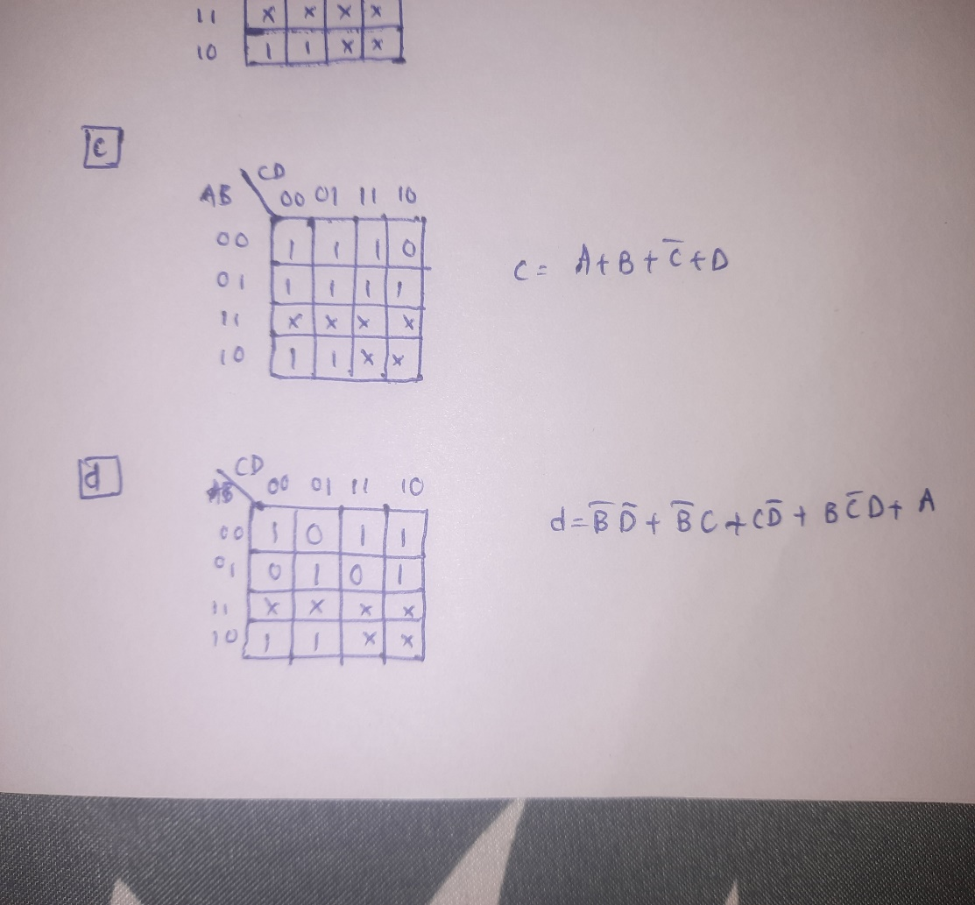

Kmap for e:

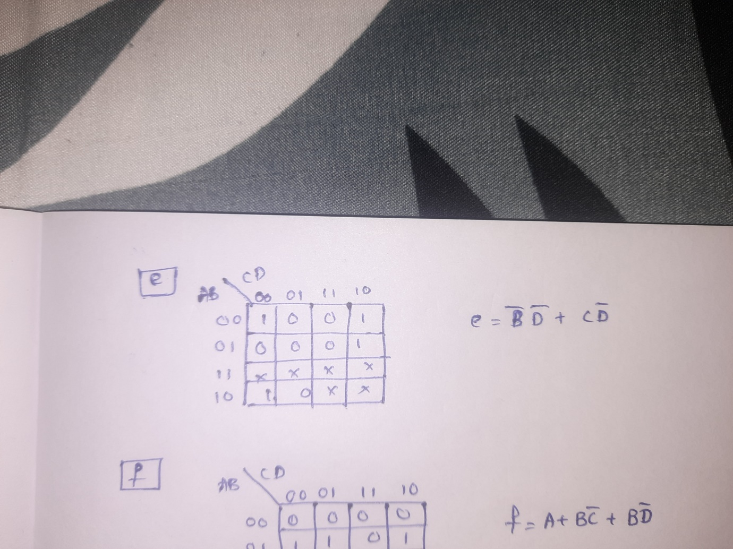

Kmap for f:

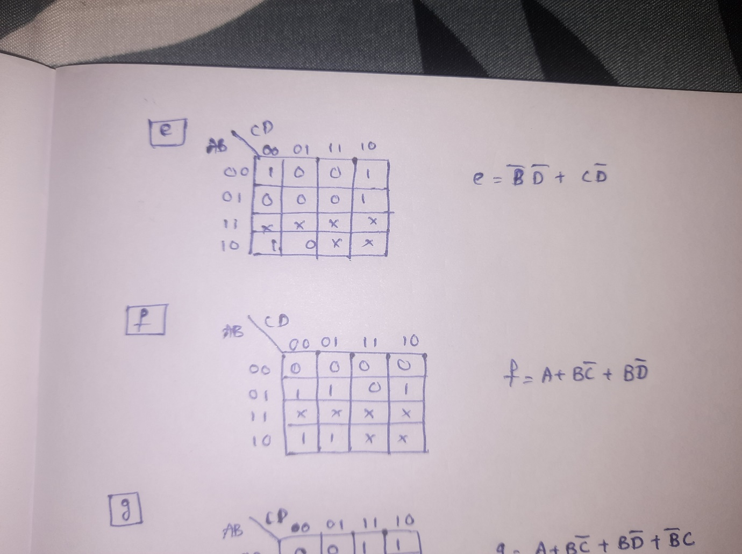

Kmap for g:

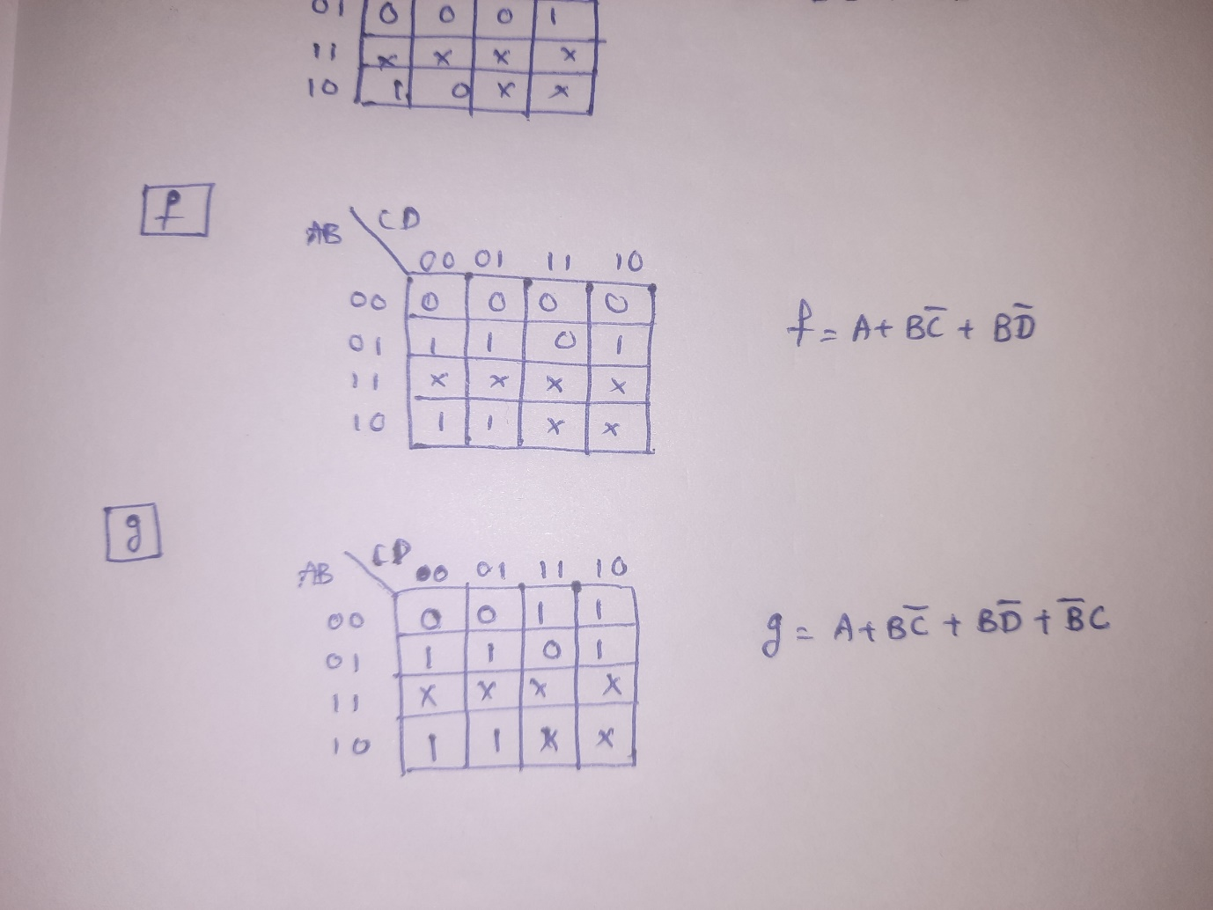

Binary to 7-segment display Decoder:

Circuit diagram

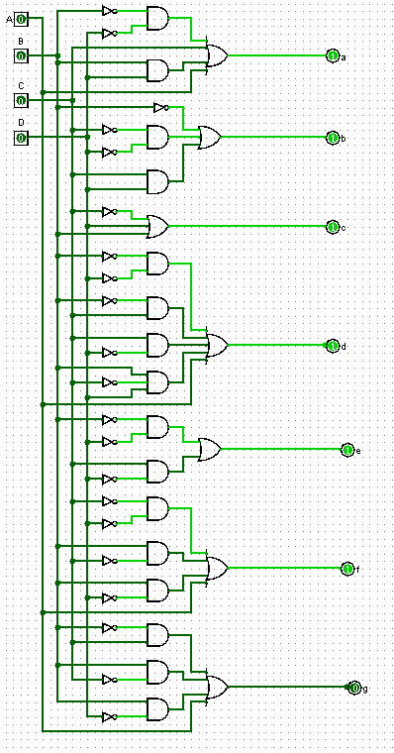

**24-HOUR CLOCK:**

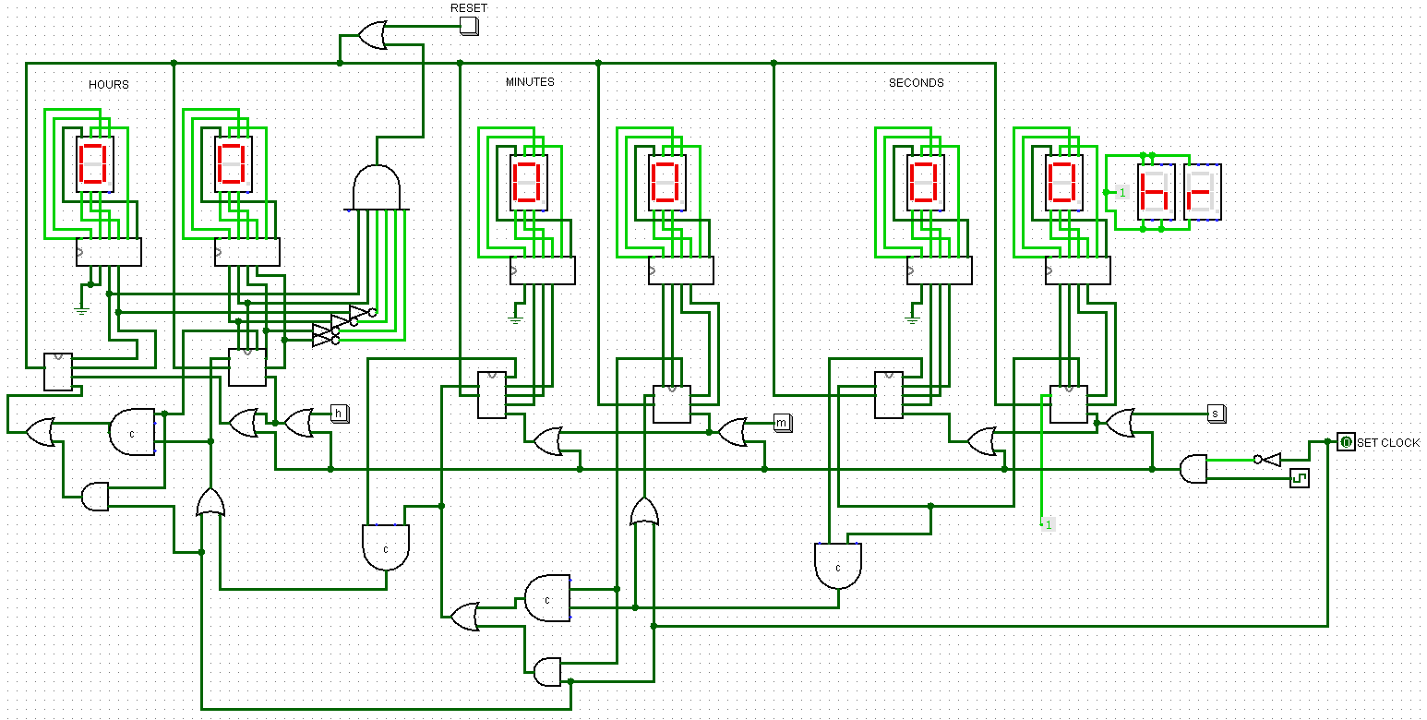

**Design Description:**

In this 24 hour clock three mod-10 counters are used, two mod-5 counters are used and one mod-2 counter.

In clock the “seconds” part contain one mod-10 counter and one mod-6 counter .

“minutes” part also contain one mod-10 counter and one mod-6 counter.

In “hours” part one mod-10 counter and one mod-2 counter is present.

SECONDS:

Mod-10 counter is designed using finite state machine (FSM).it counts from 0 to 9 only, after counting 9 it again returns to 0.the mod-10 counter contains a 9 digit detector it returns high output when the counter counts 9.the high output is given to mod-6 counter as enable.

MINUTES:

Similar to seconds part in the clock it also contains one mod-10 counter and one mod-6 counter.

i.e when 59 seconds are done in the seconds part, the high output is given as enable to mod-10 counter in minutes part ,so that it runs accordingly with respect to seconds part.

When the count in the seconds becomes 59 and mod-10 part in the minutes part become 9 then that output is given as enable to mod-6 counter in the minutes part.

HOURS:

It contains mod-2 counter and mod-10 counter.

It also works based on the enable which is connected to minutes and second part of the clock.

When the mod-10 part becomes 4 and mod-2 part becomes 2 .In this situation the whole clock is reset to initial state(i.e all zeros).

In this way the 24 hour clock works based on the counters used and the clock which is given as input.

* In this clock design there is RESET option is there.(reset button)
* And SET CLOCK option is also present ,in which we can change the time of the clock by stoping the clock once and then we can change the clock components separately like the seconds part ,minutes part and hours part can be altered separately by using the s,m,h buttons respectively.

Circuit diagram for “seconds” part of the clock:

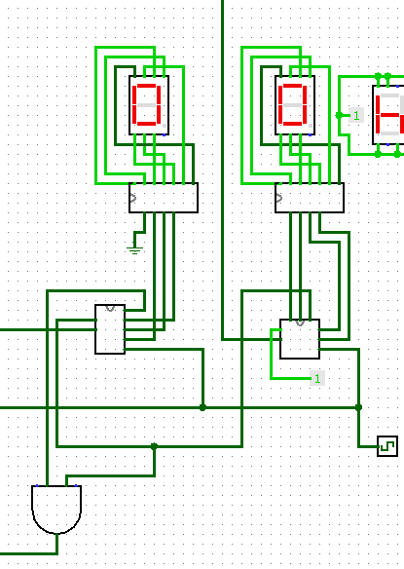

It contains mod-10 counter and mod-6 counter.

Circuit diagram for “minutes” part of the clock:

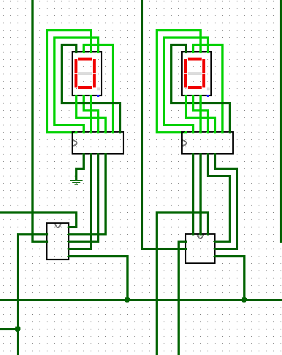

It contains mod-10 counter and mod-6 counter.

Circuit diagram for “Hours part of the clock:

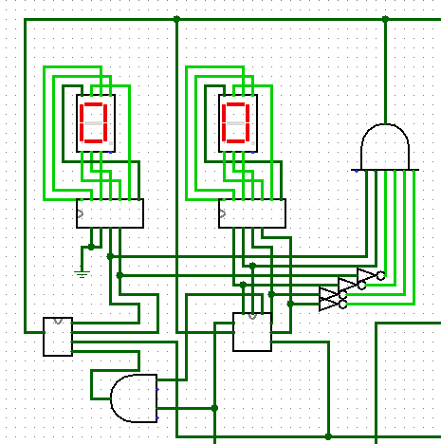

It contains mod-10 counter and mod-2 counter